|  |  |
| --- | --- |
| [*www.northmarstonhistory.org.uk*](http://www.northmarstonhistory.org.uk) | *North Marston History Club*  *Newsletter*  *October 2018*  ***“Giving the past a safe future”*** |

**The Aylesbury Duck (and Prune)**

Many thanks to those of you who came to our splendid talk on 12th September about “***The Famous Aylesbury Duck and the Less Famous Aylesbury Prune****”*. This proved to be one of our most popular talks to date. Here’s a picture of an old friend to whom we were introduced on the night.

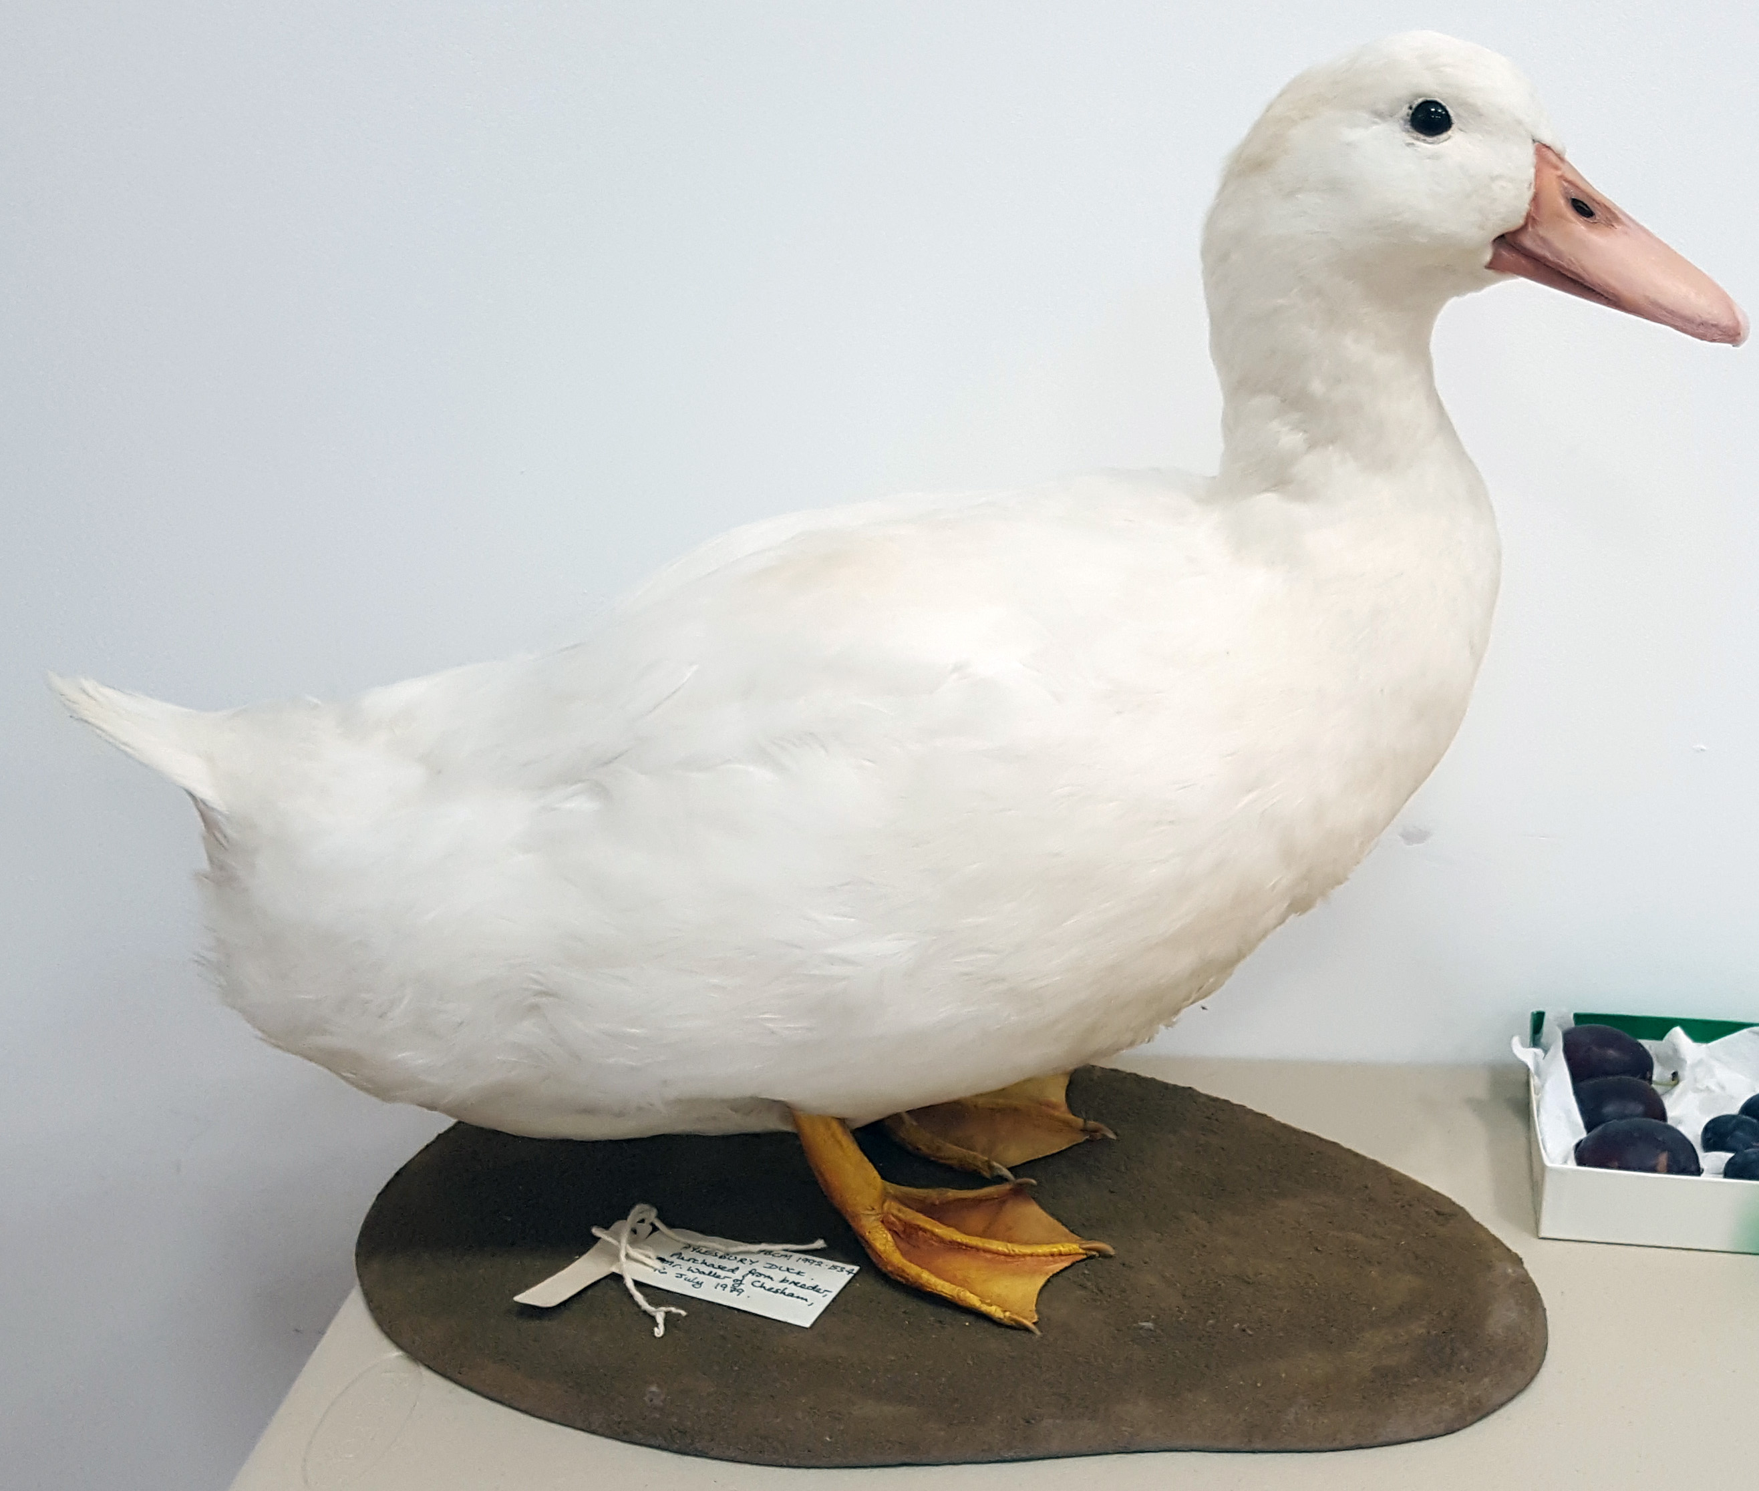

**Village Wartime Experience**

Our next event is something a little different. Entitled **“The *Village Wartime Experience*”**, we are trying to recreate the sights, sounds *and tastes* of life on the Home Front in North Marston in World War 2. The event, to be held at the Wesley Centre on October 10th at 7.30, will bring together wartime artefacts and household items, people in period dress, a series of short “Ministry of Information” films devised for the Home Front audience and some wartime recipes recreated by Tricia McSweeney for you to sample. Look out for the eye-catching posters we will soon be distributing:

Macintosh HD:Users:johnspargo:Desktop:Wartime Experience Evening:Wartime Event, final.pdf

**Calendar Sales**

We are pleased to confirm the sales of our 2018 Calendar, *“A Village Gallery*”, have gone extremely well and we have only a few now remaining. Thanks to all our customers and to Janet Gowin for her highly successful distribution and sales.



**Marston’s Great War Heroes**

In the Great War of 1914-1918 this village lost 24 men. To put this in perspective, this was more than the combined totals of Whitchurch and Oving. In our village history, *“The North Marston Story*”, we wrote:

*“an entire generation disappeared and it cast a long shadow over the village for many years afterwards.”*

These young men would have known each other, and many would have been at school and grown up together. For a small village of barely 600 people to lose 24 young men was a tragedy of huge proportions, equivalent to the loss of 10% of men of working age.

A hundred years since the end of the Great War the scale of this tragedy has slipped beyond living memory. It would be easy for these 24 men to be erased from our collective history; they then become no more than a list of names on a plaque, without meaning to the village residents of today or tomorrow.

The History Club feels that as the centenary of the end of the Great War falls on Remembrance Sunday (11th November) this year, we should try and bring those 24 men into focus and tell a bit more about them as real people., or as much as we can find out.

We will be creating a Centenary Display in the Memorial Hall…a fitting venue as it was built after the Great War to honour those that died….with panels of information and photographs seeking to “place” them in the context of the village and their families.

In partnership with the Parish Council we are also buying two “Silent Soldier Silhouettes”; one will be mounted outside the Memorial Hall and the other placed at the church, adjacent to the “Roll of Honour” identifying those local men who gave their lives in the Great War. Please come to the Remembrance Day event at the Memorial Hall and spend a few minutes looking at our display that is being created by our Secretary, Sue Chaplin.

**And finally….. fancy a day trip?**

Following our very successful minibus trip to the Military Intelligence Museum, we are planning another trip, this time to the award-winning Milton Keynes Museum. With thousands of items and interactive displays, as well as a tea-room and gift shop, this has been highly recommended to us by people who have been there. We haven’t a specific date in mind, but if there is enough interest we’ll book a minibus on a week-day in the second half of October. We would aim to leave the village at about 10.30 and return about 4.00. We make a small charge of £12.00 towards the cost of the transport (the History Club will subsidise the rest). Interested? Call John Spargo on **01296 670225**

Thank you for your continued support.

**John Spargo**