North Marston History Club

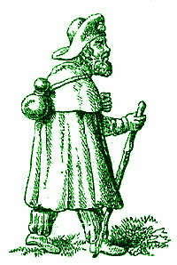

is proud to host

The Marston Mummers’ Play

first performance at

**The Wesley Centre, Thursday 20th December**

**At 6.30 pm.**

**A modern revival of a traditional English folk-play featuring St George, Bold Slasher, Father Christmas, Dr John Schorne, Happy Jack and Beelzebub.**

**Mummers’ Plays are performed by local actors….”Mummers”…and last about 15 minutes. Mummers’ Plays can be traced back to the 1200s and were still being performed up to the Great War. They are said to be the origin of the pantomime. Our first Marston Mummers’ Play will draw upon an old Quainton script as well as other scripts.**

*Suitable for all ages….come and join in the fun*

More details about all the performance venues will be in the December Parish Magazine.