 | North Marston History Club  Newsletter July 2020

Adaptability is the name of the game throughout these strange times. Although we aren’t able to hold our regular evening talks, we have re-booked all the speakers for next year.
Meanwhile, we haven’t been idle. The executive committee continues to hold its monthly meetings via Zoom, and we are planning a calendar for sale later in the year.
Films: We have published three films in the “Walking Through History” series and you can access all three films from our website (www.northmarstonhisrory.org.uk) by clicking on the “Films” tab on the top toolbar. The three latest films are “Chapel Green to Hagditch”, “Ponds and Footpaths” and “Paths to Salvation”. Alternatively, you can download them onto your smartphone or tablet by using the camera to scan one of these QR codes.

 |  | 
Chapel Green to Hagditch | Ponds and Footpaths | Paths to Salvation

And finally, it was the sixth anniversary of the publication of our village history The North Marston Story on 5th July. The picture captures the event when Trevor Lane was the guest of honour and formally launched the book. We have achieved much since then, including the creation of our Heritage displays at the Wesley Centre, but it was the launch of The North Marston Story that really put us on the map. This October sees the 10th birthday of the club. | 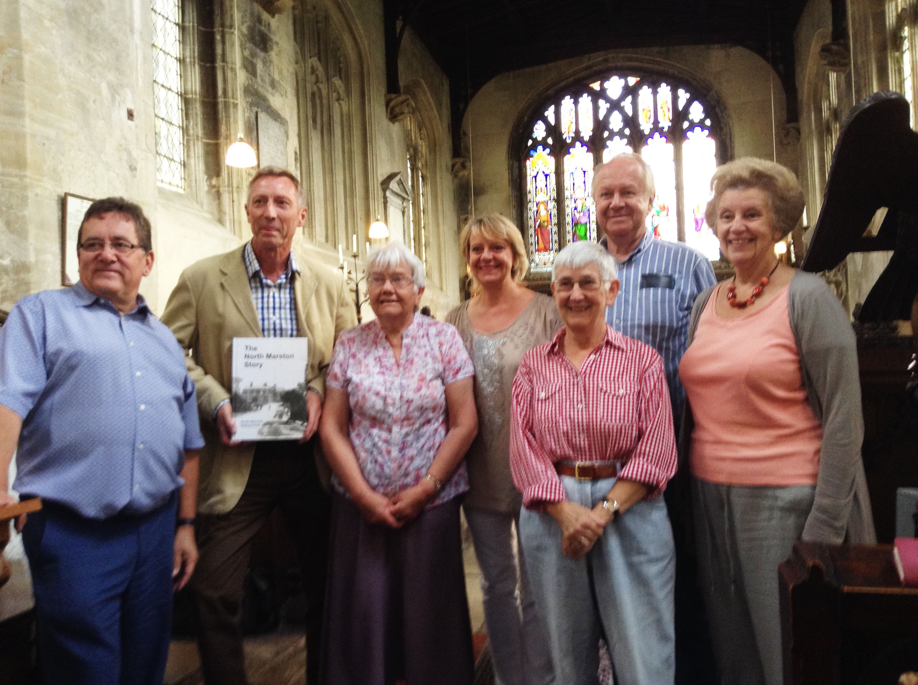  John Spargo  Chairman NMHC

