**Colin Price**

**23rd January 1945 to 26th October 2020**

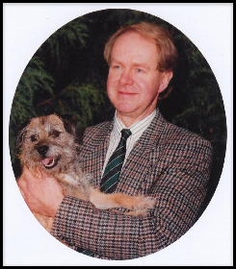

It was with immense sadness that we said our final goodbyes to our Treasurer, Colin Price, whose funeral took place today at North Marston church. Colin was one of the founder members of the History Club and our Treasurer from its inception.

It is hard to imagine the History Club without his calm, steadying influence. He brought wisdom and perspective to all our discussions and in many senses provided us with a compass for our decisions. He was an integral part of the growth of the club from the start, offering reassurance each step of the way, a check against our excesses, yet positive and encouraging as we broke new ground.

Outside the History Club, Colin was a massively respected and liked member of our community, intrinsically embedded within the heart of much of what happened in North Marston. His knowledge and interest in history was an invaluable asset to us, and he wrote a number of the chapters in our village history book, The North Marston Story.

Colin has left the Club’s Executive Committee with a legacy of memories, and at every decision to be taken in the future someone is bound to ask: “Well, what would Colin say?”

***History Club Executive Committee, 13th November 2020***