NORTH MARSTON “SNOWSCENE”CHRISTMAS

CARDS

are now on sale in The Shop

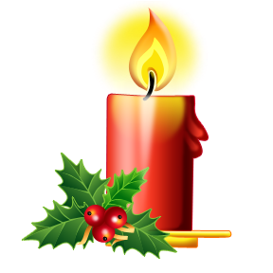

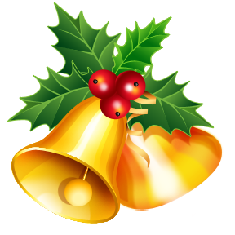

***£4.50 a pack of five***

***6” x 4” with envelopes***

Hurry while stocks last!

Unique and special cards for close friends and family