North Marston’s Threshing Barn: Proposals for its Future Use by North Marston History Club

Quainton Road in North Marston was home to most of the village’s labour force including many of the village’s small-holders. Some of the buildings in Quainton Road are listed but most are not. What they all share in common is that they fall outside the Conservation Area and therefore do not enjoy the environmental protection a Conservation Area confers. One of these important village buildings is The Threshing Barn. See pictures below).

The Threshing Barn is also referred to as the Harvest Barn, the Labourers’ Barn and the Parish Barn. It was built in 1888 for farm labourers to thresh their own harvest. Labourers grew a small crop of cereals to feed their chickens for egg production. Up to that time, one or more farmers had allowed labourers to use their barns to thresh the corn but over the years less space became available.

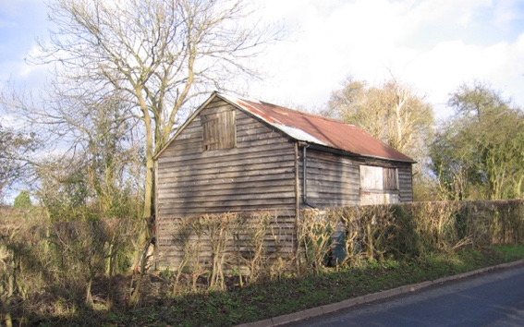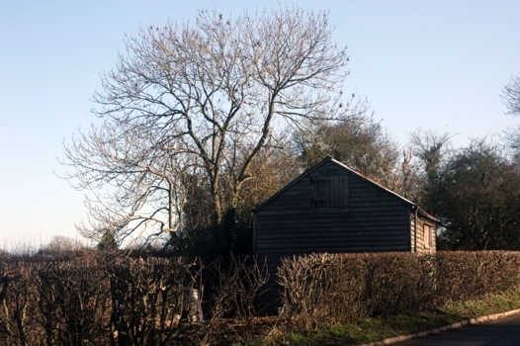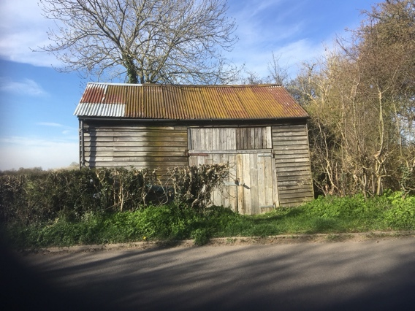

When, in October 1888, Mr Kibble told the labourers that the barns at Glebe Farm were too full that year for him to be able to let the men thresh there, an emergency meeting was called. A large number met in the Parish Schoolroom on October 5th and the plan to build an independent barn for the use of farm labourers of the village was conceived. A committee was elected with Alfred Carter as chairman. Fund raising events were held; the barn was primarily financed by donations from individuals from within and outside the village. A remarkably large number of people donated; it seemed that everyone gave what they could afford albeit small amounts in many cases.

The barn was formally opened on 29th December 1888 less than three months after the first meeting. A celebratory “Barn Tea” was attended by 130 people. There was a long list of self-congratulatory speeches and the vicar cheerfully accepted compliments for his role in the venture. There was much praise for the concept of “helping those who helped themselves” and an expression of hope that the barn would not be used for political or religious meetings!

The barn was built by local builder John Price at a cost of twenty six pounds. The total cost including all expenses amounted to £32 5s 0d.

The Barn Today

The Barn features in the village Heritage Trail and carries a plaque denoting it as being an important building in the social history of the village. It is undoubtedly a Heritage Asset. Concerns over the increasing dilapidation of the structure have raised questions about the future of The Barn, an asset owned and managed on behalf of the village by the parish council. The barn is currently rented out by the parish council for storage.

For some time, North Marston History Club has considered whether the barn could be “re-purposed” to display artefacts that would have been used by the small-holders for whom the barn was built. This would include the renovated, original winnowing machine that is in storage in the village as well as the numerous hand tools, most locally made, that would have been very familiar to the barn’s original users. The Club would access grants for the cost of the scheme which creates a recreation of a “Victorian Threshing Barn”.

With the original 1880s winnowing machine, mannekins posed in period costume and a display of locally made tools for threshing, ditching, hedging and farming it would offer a glimpse into the rural world before mechanisation.

This would be achieved via a grant-funded project comprising a weatherproof “lining” inside the original timber structure, with the roof also weather-proofed from inside. “Sun Tube” illumination would be used for the main space (as is fitted to the village shop).

The display will be viewed from the outside without requiring access, thus alleviating the need for the barn to be “manned” for visits. To achieve this, a viewing window will be installed on the north-east flank wall. The front face of the barn, with its double doors, will remain un-changed in appearance.

